Treasurers’ Training—District 29 TLI, Dec 3, 2016
Dana G. Richard, DTM

Club Mission: We provide a supportive and positive learning experience in which members are empowered to develop communication and leadership skills, resulting in greater self-confidence and personal growth.

Your role as treasurer as stated in the Club Constitution and Standard Bylaws of Toastmasters International is: “The treasurer is responsible for club financial policies, procedures, and controls. The club treasurer receives and disburses, with the approval of this club, all club funds; pays to Toastmasters International all financial obligations of this club as they come due; and keeps an accurate account of all transactions. The club treasurer shall make financial reports to this club and to the club executive committee quarterly and upon request, and shall transmit the accounts and all undistributed funds to the successor in office at the end of the club treasurer’s term.”

Treasurer Responsibilities:
- Before club meetings:
  - Prepare a financial report
- During club meetings:
  - Collect membership dues
  - Report on club finances
- Outside the club meeting:
  - Prepare a budget
  - Provide bank with a signatory card
  - Collect and pay dues
  - Submit new member applications
  - Issue checks for club expenses
  - Keep financial records
  - Present financial reports
  - Submit club accounts for audit
  - Attend executive committee meetings
  - Reconcile deposits, expenditures and cash on hand
  - Ensure club meets government tax regulations
  - Receive financial correspondence
  - Prepare for audit committee
- Executive Committee:
  - Prepare a budget
  - Present financial reports
  - Submit club accounts for audit
  - Work with executive committee on Club Success Plan
- Reimbursement for Open Houses

Benefits:
- Improve accounting and organizational skills
  - Receiving and managing money
  - Preparing budgets
  - Keeping accurate records
  - Disbursement of funds
- Helps fulfill Advanced Leader Bronze requirements

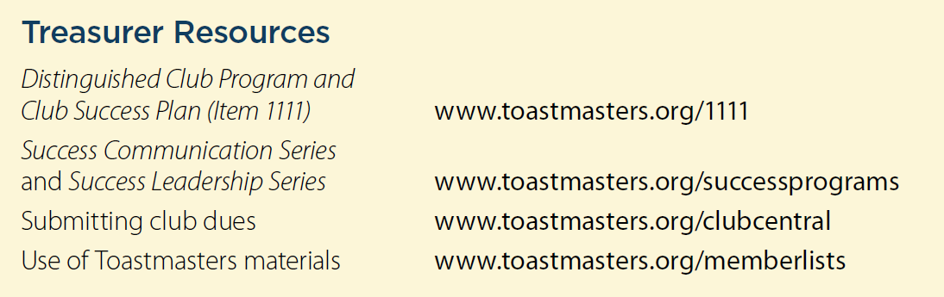
The Club Leadership Handbook, pp. 37 - 40
District 29 Finance Manager Venita Hawkins, CC, CL: financemgr@tmd29.org

