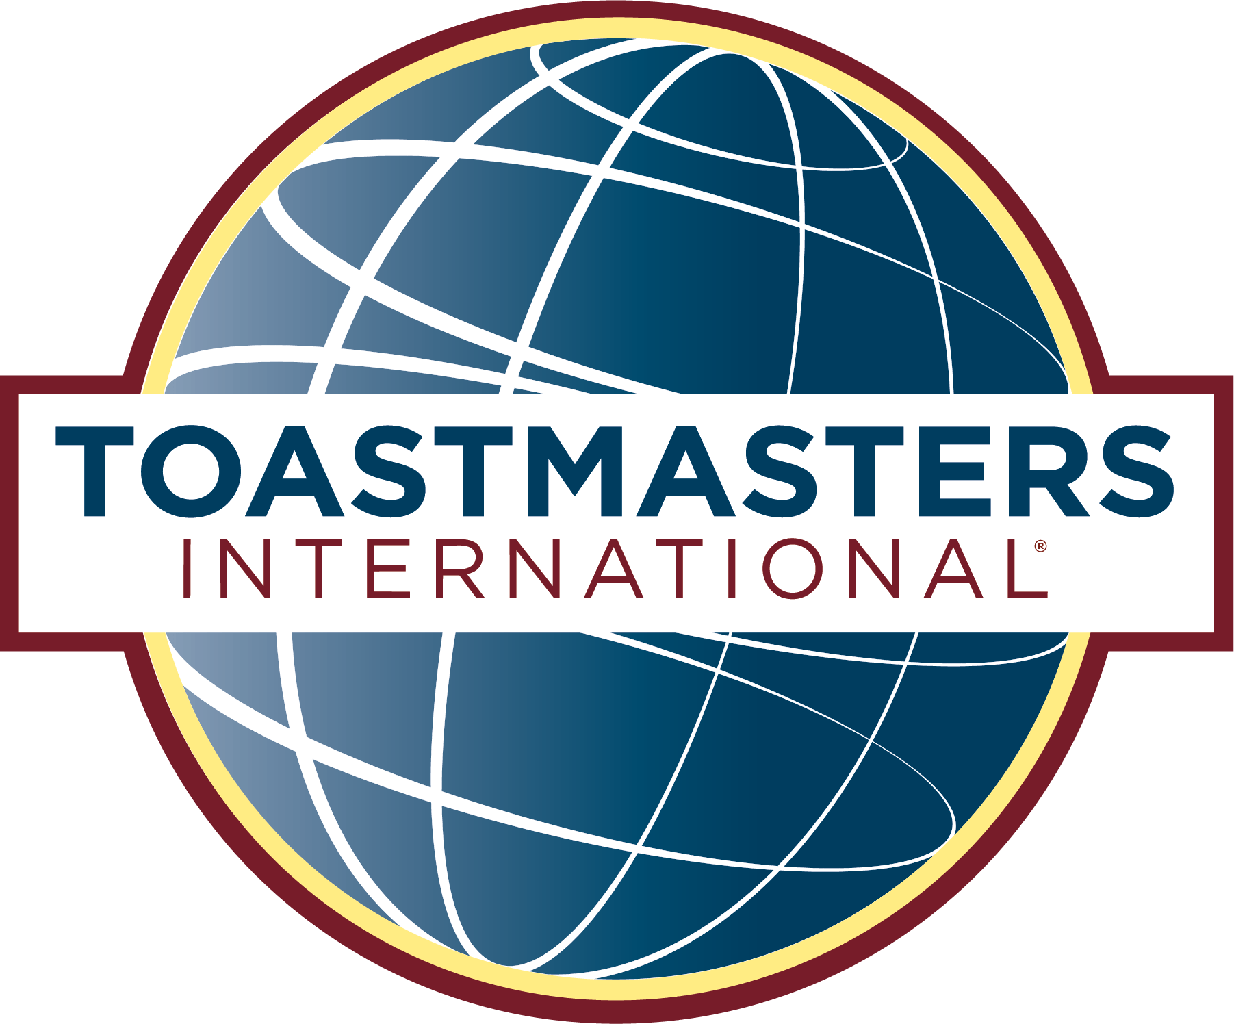

Hybrid meetings—are they for you?

A guide to help you decide whether or not to conduct

hybrid meetings.

Before going through the process of planning how your club can hold hybrid meetings, i.e., a combination of in-person and on-line participants, you should carefully consider whether your club should have them. They may be a good idea and offer many benefits, or they may actually hinder your members’ growth as speakers. It is also possible that it may cost too much in either time or money to be practical, especially if they only benefit a very few members or if your club is small—the level of cost and effort may not actually be worth the return in some cases. It is important to think through this before deciding to actually do them. So before delving into the mechanics of how they can be done, and for this I refer you to my User’s Guide for Conducting Hybrid Meetings, let us consider the advantages and disadvantages of doing them and consider some important questions.
This guide is intended to help guide the discussion for your club, but the actual decision is, of course, up to you.
Advantages |  | Disadvantages
Can allow temporarily remote members (vacationing, on business trips, etc.) to participate |  | Can lead to a tendency to be less professional in dress and demeanor
Can allow members outside the club’s immediate geographic area |  | May require resources that are not readily accessible
Can allow meetings to continue during adverse weather (allows an option to not attend physically, but an entirely on-line meeting might be a better option in many cases) |  | Can hinder development as a speaker (more difficult to use gestures and maintain audience eye contact, use of speaking area)
Provides opportunities to learn how to communicate effectively on-line (i.e., how to use the medium to advantage) |  | Can reduce development of personal relationships that are beneficial for club and personal growth
Can allow members who cannot travel to the meeting to participate |  | Are subject to frustrating technology failures that can cause participants to drop off or freeze
Can make media-based projects such as podcasts and webinars more effective |  | Can reduce interaction with the audience
Can provide opportunities to learn technical skills |  | Can be derailed by someone forgetting a critical component

Questions that should be “Yes” | Yes | No | Score  +1 for Yes 0 for No
Will it enhance the member experience?
Will it contribute the club attaining excellence?
Will it increase the education benefits available to the club’s members?
Will it increase the professionalism of the club?
Does the club have, or is it willing to obtain, the resources required to conduct effective hybrid meetings? (Some club members may already have some or all the required equipment and may allow the club to use it—but responsibility for ensuring it shows up must be clearly planned and understood.)
If you are borrowing a club member’s equipment, will it consistently be available for club meetings?
Will the club’s physical meeting space accommodate the set-up required to permit participants to join remotely?
Is having members join on-line even available as an option at the meeting’s physical location(s)? (e.g., is Wi-Fi available, is there power)
Will members joining remotely be integrated fully into the meeting? (i.e., effectively fill any required meeting role, not just speakers and observers)
Will enough members be likely to participate remotely to justify the expense and level of effort of doing them?
Will enough members by participating in-person to justify the expense and level of doing them?
Are you willing to put in the set-up and break down time that doing this will require to do well?
Can the club obtain/provide required training?
Score
Clubs must decide for themselves what an acceptable score is for hybrid meetings to be viable, but as a minimum it should be at least half. Also, clubs may "weight" the questions scoring to account for specific issues that are of greater concern to the club than others.
Questions that should be “No” | Yes | No | Score  -1 for Yes  0 for No
Will holding hybrid meetings result in an unreasonable burden being placed on a small number of members?
Will it create friction amongst members that could weaken the club?
Will it place any of the club’s members at a disadvantage?
Will it reduce the quality of meetings (more difficulty starting on time, more difficult to include all members, distractions and delays caused by technical difficulties, etc.)?
Score
As with the "Yes" questions above, clubs must decide how many "No's" is too many; half or more is probably a good benchmark but in your club just one might be too many. Again, the questions can be weighted to allow for issues of particular concern.
You can also subtract the "No" score from the "Yes" score to arrive at an overall score that might be a useful guide. If a "perfect" score is 16, then a club can establish a minimum acceptable score that is required before deciding to hold hybrid meetings.

